Report On

TOURIST MANAGEMENT SYSTEM

Submitted in partial fulfillment of the requirements of the Mini project in
Semester III of Second Year Artificial Intelligence & Data Science Engineering

by
Pratik Sanjay Avhad (01)
Priyanka Narendra Bhandari (02)
Swarup Satish Kakade (19)

Under the guidance of
Prof. Sejal D’mello
Prof. Neha Mahesh Raut



University of Mumbai

Vidyavardhini's College of Engineering & Technology

Department of Artificial Intelligence and Data Science

(A.Y. 2023-24)



CERTIFICATE

This is to certify that the Mini Project entitled “TOURIST MANAGEMENT SYSTEM ” is a bonafide work of Pratik Sanjay Avhad (01), Priyanka Narendra Bhandari (02), Swarup Satish Kakade (19), submitted to the University of Mumbai in partial fulfillment of the requirement for the award of the degree of “Bachelor of Engineering” in Semester III of Second Year “Artificial Intelligence and Data Science”.

_____________________  Ms. Sejal D’mello  Guide |  | _____________________  Ms. Neha Raut  Co-Guide
________________ | ____________________ | _______________
Ms. Sejal D’mello  Deputy HOD AI & DS | Dr. Tatwadarshi Nagarhalli  HOD AI &DS | Dr. H.V. Vankudre  Principal



Mini Project Approval

This Mini Project entitled “TOURIST MANAGEMENT SYSTEM” by Pratik Sanjay Avhad (01), Priyanka Narendra Bhandari (02), Swarup Satish Kakade (19) is approved for the degree of Bachelor of Engineering in in Semester III of Second Year Artificial Intelligence and Data Science.

Examiners

1………………………………................
(Internal Examiner Name & Sign)

2…………………………………………
(External Examiner name & Sign)

Date:
Place:

Contents

Abstract i

Acknowledgment ii

List of Abbreviation iii

Introduction 1
  - Introduction
  - Problem Statement & Objectives
  - Scope

- Literature 2

  - Survey of Existing System/SRS
  - Limitation Existing system or Research gap
  - Mini Project Contribution

Proposed System 4

  - Introduction
  - Architecture/ Framework/Block diagram
  - Algorithm and Process Design
  - Details of Hardware & Software
  - Implementation and Results for Validation and Verification
  - Analysis
  - Conclusion and Future work.

References 9

Abstract
The Tourism Management System is a comprehensive software solution designed to streamline and enhance the management of tourist services. It is an web application project used for acquiring information about particular city's hotels, restaurants, historical places, etc.
This project offers a user-friendly platform for tourists to plan and book their trips, accommodations, and activities. It also assists tour operators and destination management organizations in efficiently organizing and promoting tourism services. This application is based on the idea that travelers rely on other.
Traveler reviews to plan their trips Key features include real-time booking, itinerary customization, and detailed information about destinations. With a focus on user convenience and data accuracy, it aims to revolutionize the tourism industry by providing a seamless experience for both travelers and service providers.

I
Acknowledgments

I would like to thank all people whose support and cooperation has been an invaluable asset during this Project. I would also like to thank our Guide Prof. Ms. Neha Mahesh Raut, for guiding me throughout this project and giving it the present shape. It would have been impossible to complete the project without his/her support, valuable suggestions, criticism, encouragement, and guidance.

I convey my gratitude to Dr. Tatwadarshi Nagarhalli, Head of Department, for his motivation and providing various facilities, which helped us greatly in the whole process of this project. I am also grateful to all other teaching and non-teaching staff members of the Artificial Intelligence and Data Science Department for directly or indirectly helping us with the completion of projects and the resources provided.

------------------------------
Pratik (01)

------------------------------
Priyanka (02)

------------------------------
Swarup (19)

Date:

ii

List of Abbreviations

- HTML:- Hypertext markup language.

- CSS:- Cascading Style Sheets.

- JS:- JavaScript.

- PHP:- Hypertext preprocessor.

- SQL:- Structured Query Language.

iii
- INTRODUCTION

A travel website is a website that provides travel reviews, trip fares, or a combination of both. Over 1.5 billion people book travel per year, 70% of which is done online.

According to the United Nations World Tourism Organisation (UNWTO), tourism entails the movement of people to countries or places outside their usual environment for personal or business/professional purposes.

Tourist management system is used to book a tour from anywhere in the INDIA by a single dynamic website which will help the user to know all about the places and tour details in a single website. The admin can add packages to the website from a certain travel agents and hotels by create a tour page. Then the users can sign in and book each project. It is a easiest platform for all travelers which can be easily booked and know the all details. Tour Management system is a dynamic website for tourism business.

The development and implementation of a Tourist Management System, discussing the technology behind it, the software requirements, the development process. Our goal is to demonstrate the feasibility and functionality of such a web application, showcasing its potential tourist management.

1.2 Overview

Weekends is a Online Travel Management Website used to view packages, gallery, and user can explore the cities. The main aim of Weekends is to provide good facilities to user through online.

1.2 Problem Statement & Objective

Problem Statement:

India is a country where in a few days holiday, you can enjoy a lot .The problem is that we although having many websites but they offer different kind of services .The customers are enjoying a lot but there is a lack of relationship between travel agency and customers and hence we are establishing that relationship by caring and serving all customers in the same manner that we wish to be served.One of the main purposes of the website is to facilitate the offline customer online because customers cannot spend their precious time in markets trying to find out the best deal and provide them good facilities and right information. Because of the manual maintenance there are number of difficulties and drawbacks exist in the system. Since the last few years, Indian tourism industry has been growing at a rapid pace. Many tourism-related activities have been suspended due to the nationally enforced lockdown to combat the Coronavirus pandemic. The tourism industry suffered immensely from the lockdown, and as a result of this, digital tourism began gaining traction and attracted public attention.

Weekends is here to provide the facilities to user and to provide information of some cities and give preview of hotel and flights.

Objectives:

Our priority will be our customers and their travel requirements.
- Interface :-
There will be many users visiting the portal and hence we require a strong and reliable frontend which can withhold the users on our site.

- Efficiency :-
The data we will be consisting is very important that can help everyone and hence we need a strong database.

- Cheapest:-
To offer the traveling services at very reasonable prices.

- Contact Us :-
We need to build a world class team armed with knowledge and backed by technology to advise customers in planning of their holidays and to answer their queries.

- Accuracy:-
We will be putting an effort to provide the right choice to the people when they plan a holiday and beware them from the false advertising.

- Simple:-
The purpose of travel sites is to make it easier for people to plan their trip.
They provide a wide range of services, from helping you find the best deals on flights and hotels, to providing detailed information about destinations around the India.

1.3 SCOPE

This website serves as a comprehensive platform for travelers and tourism service providers. This website can offer features like user registration, itinerary planning, hotel and transportation booking, and reviews. Travelers can explore destinations, create customized itineraries, book accommodations, flights, and tours, and view packages. Additionally, user can view map.
For tourism service providers, the website can include tools for managing inventory, tracking reservations. Furthermore, data analytics can be integrated to offer insights into travel trends and customer preferences. Overall, a tourist management system website provides a robust and user-friendly interface for both travelers and industry professionals.

1
2 Literature Survey

Madushan S.H.K , “Travel Planning Management System”
This research, "TRAVEL PLANNING MANAGEMENT SYSTEM", is used to automate all processes of travel and tourism, which deals with the creation, booking, confirmation, and user details. The project is designed with React JS as the front end and Spring boot as the backend, which works in any browser. A travel planning management system is used to book a tour from anywhere in the world by a single dynamic website which will help the user to know all about the places and travel details in a single web application. The admin can add travel packages to the system, transport services, place management, and hotels to create travel packages. Then the users can sign in and book each travel package, and also, they can book custom travel packages. The user can confirm their bookings by paying for the package. It is the most accessible platform for travellers who can easily book and know all details.
Some of them are Drawbacks of the Existing System:
- Increased transaction leads to increased source document and hence maintenance becomes difficult.
- If any admin, user entry is wrongly made then the maintenance becomes very difficult.

Kuchekar Rutvik Baban, “Tours and Travel Management System”

This project “tour AND TOURISM control” is used to automate all procedure of the travel and tourism, which deals with creation, booking and affirmation and person info. The undertaking is designed HTML-Hypertext Preprocessor as front cease and Microsoft sq. Server 2008 as backend which fits in any browsers. The coding language used HTML and php. tour and tourism management device is used to e-book a excursion from everywhere within the world by using a single dynamic internet site in order to help the consumer to recognise all approximately the places and tour information in a single website. The admin can upload programs to the internet site from a sure journey retailers and hotels by using create a tour web page. Then the users can check in and book every mission, they may be showed by way of the admin of their control reserving web page. The person can see the confirmation of their my booking web page. it's far an easiest platform for all tourists which can be without problems booked and recognise the all details. key phrases: journey and tourism management, tour programs, tourism, package booking.

2.1 Survey of existing system

SR NO. | Paper Title | Published Year | Methodology

  - LIMITATION IN EXISTING SYSTEM OR RESEARCH GAP

The limitations in the existing system for tourism management in India, as described, can be summarized as follows:

- Manual Maintenance: The reliance on manual record-keeping for tasks and schedules is time-consuming and costly, making it challenging to manage and keep accurate records.

- Data Accuracy: Due to manual data entry, there is a risk of errors and inaccuracies in the information, which can affect the quality of service provided to travelers.

- Difficulty in Maintenance: If an admin or user makes an erroneous entry, rectifying and maintaining the system becomes a complex and labor-intensive task.

- Lack of Efficiency: The existing system lacks efficiency in terms of managing tasks, schedules, and data, which can lead to delays and suboptimal results.

Research Gap:

The research gap in the Indian tourism industry, based on the described limitations, could revolve around the need for modernization and automation in tourism management systems. Researchers could explore and address the following areas:

- User-Friendly Interfaces: Designing user-friendly interfaces for both administrators and travelers to facilitate error-free data entry and access.

- Scalability: Investigating scalable solutions that can handle increased transaction volumes as the tourism industry continues to grow.

- Cost-Effective Solutions: Research into cost-effective digital tools and methods that can replace or augment manual processes, making tourism management more accessible and affordable.

  - MINI PROJECT CONTRIBUTION

A basic tourist management system website plays a crucial role in society by facilitating efficient tourism experiences. It serves as a user-friendly platform where tourists can access essential information about destinations, accommodations, and local attractions. This not only enhances the overall travel experience but also promotes responsible tourism.

The website contributes to society in several ways. It promotes cultural exchange by showcasing the unique heritage and traditions of various regions. Additionally, it supports local businesses by directing tourists to local hotels, restaurants, and shops.

Furthermore, this tourist management website can improve safety and security for travelers by providing contact number and travel advisories. It also encourages environmental awareness by promoting eco-friendly practices.

3

3. PROPOSED SYSTEM

  - ARCHITECTURE/FRAMEWORK /BLOCK DIAGRAM

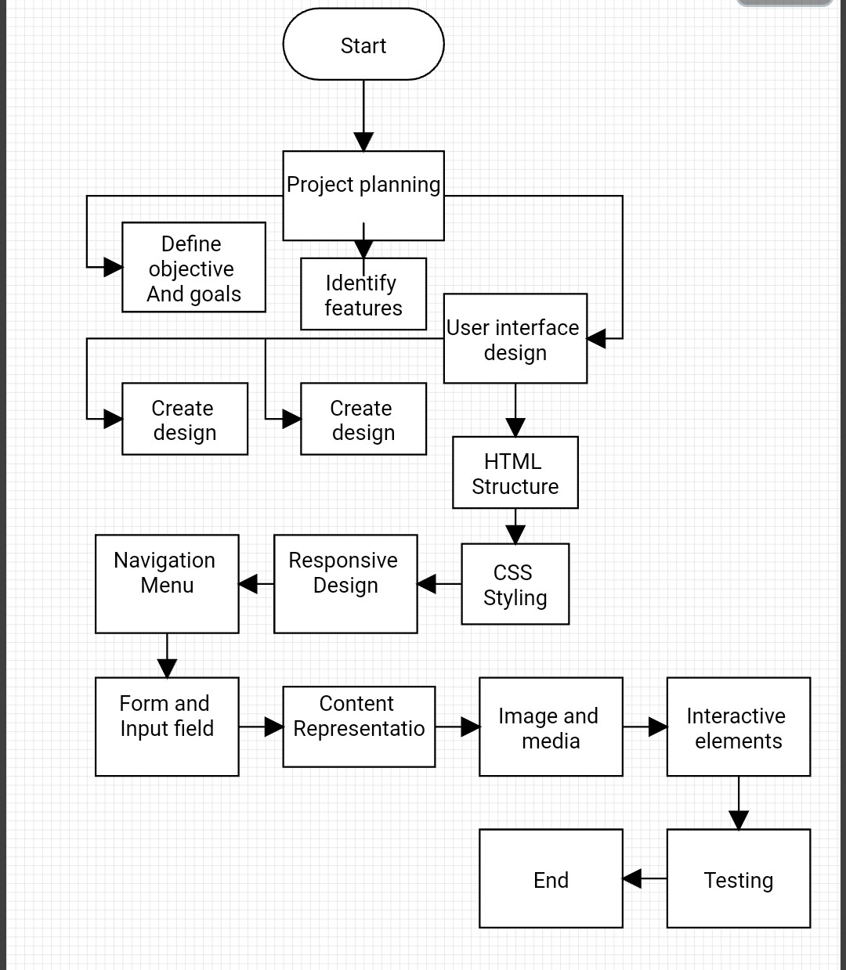

4

  - ALGORITHM AND PROCESS DESIGN

Step by step algorithm

Step 1. *Project Planning:*
- Define the objectives and goals of the tourist management system.
- Identify the key features and functionalities to be implemented in the user interface.

Step 2. *User Interface Design:*
- Create wireframes or mockups of the system's web pages.
- Design the layout, structure, and navigation of the application.

Step 3. *HTML Structure:*
- Create the HTML structure for each web page using HTML tags.
- Include the necessary HTML elements such as headers, navigation menus, forms, and placeholders for content.

Step 4. *CSS Styling:*
- Write CSS code to style the HTML elements.
- Apply fonts, colors, backgrounds, and other visual attributes to make the interface visually appealing.

Step 5. *Responsive Design:*
- Ensure that the web pages are responsive by using CSS media queries to adapt the layout to different screen sizes (e.g., mobile, tablet, desktop).

Step 6. *Navigation Menu:*
- Implement a navigation menu to help users move between different sections of the system.

Step 7. *Forms and Input Fields:*
- Create forms for user input, such as registration, login, and search forms.
- Validate form input on the client-side using JavaScript and on the server-side with PHP (not covered in HTML/CSS alone).

Step 8. *Content Presentation:*
- Display information about tourist destinations, packages, or any relevant data using HTML elements like headings, paragraphs, and images.

Step 9. *Images and Media:*
- Incorporate images and multimedia content to showcase destinations and attractions.

Step 10. *Interactive Elements:*
- Add interactivity with HTML and CSS, such as hover effects, buttons, and transitions to enhance the user experience.

Step 11. *Testing:*
- Test the user interface on different browsers and devices to ensure compatibility and responsiveness.
- Verify that all links and navigation work as expected.

Step 12. *User Feedback and Iteration:*
- Collect feedback from users and stakeholders.
- Make necessary adjustments and improvements to the user interface based on the feedback received.

Step 13. *Documentation:*
- Document the HTML and CSS code for future reference.
- Create user manuals or help guides for end-users if needed.

Step 14. *Version Control:*
- Consider using version control systems like Git to track changes in your HTML and CSS files.

Step 15. *Collaboration:*
- If working in a team, ensure effective collaboration and communication.

Step 16. *Final Review:*
- Perform a final review of the user interface to confirm that it meets the project's requirements and objectives.

Step 17. *Deployment:*
- Upload your HTML and CSS files to a web hosting server for public access.

Step 18. *Maintenance:*
- Regularly update and maintain the user interface to fix any issues, improve performance, and implement design enhancements.

  - DETAILS OF HARDWARE AND SOFTWARE

Hardware Details:
1. Edition: Windows 11 Home Single Language.
2. Processor: 12th Gen Intel(R) Core(TM) i5-1240P 1.70 GHz
3. Memory: Sufficient RAM for quick data access( 8-16 GB).
4. Storage: Adequate storage space for image and attendance data (256 SSD).
5. Network Connectivity: Internet or intranet access for data sharing (if needed).
6. System type : 64-bit operating system, x64-based processor
Software:

Software Details:
- Web server Software :- Examples including Xampp Server.

- Programming Languages :- Such as HTML, CSS, JS , PHP.

- Database Management System:- MySql.

5
  - EXPERIMENT AND RESULT FOR VALIDATION AND VERIFICATION

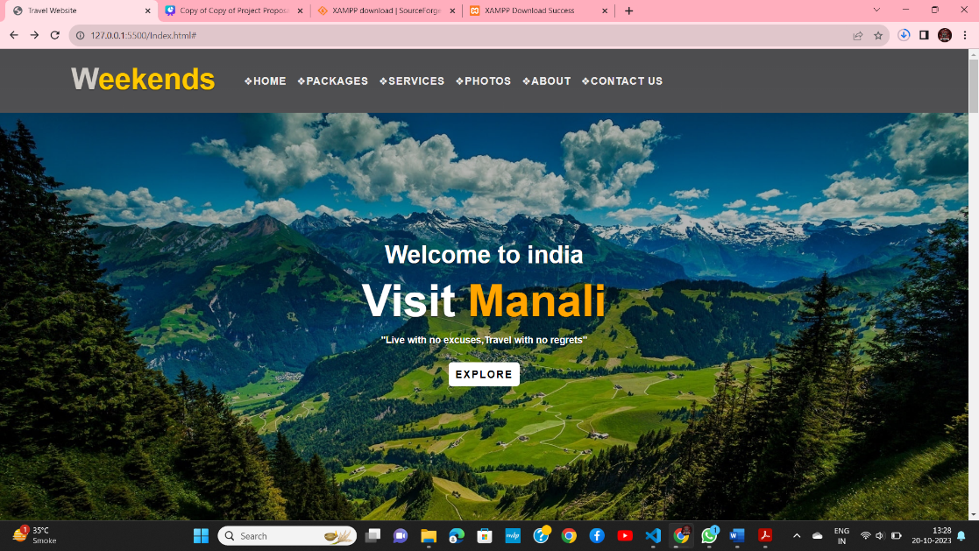

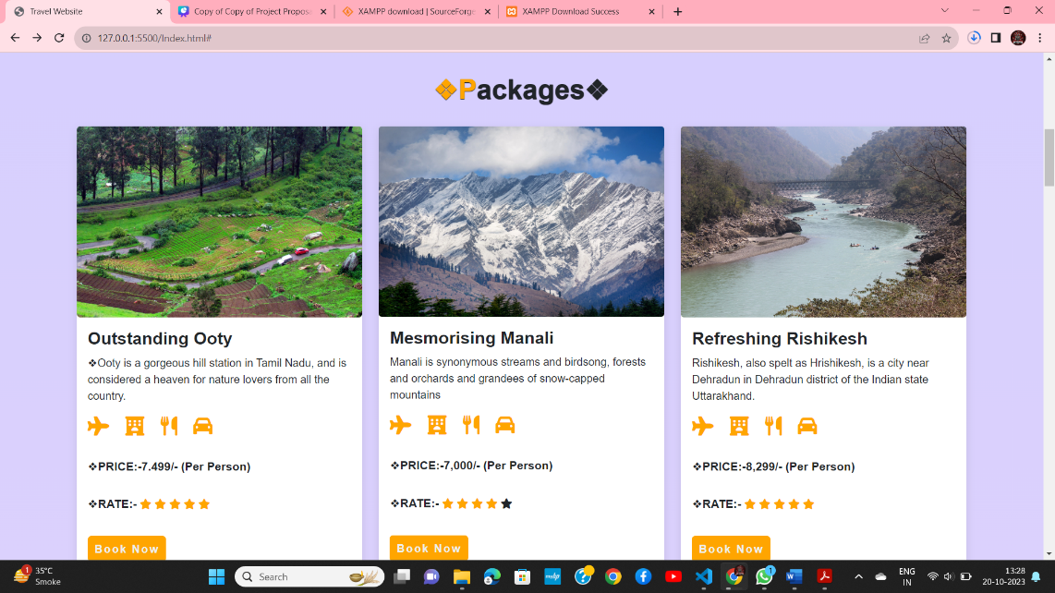

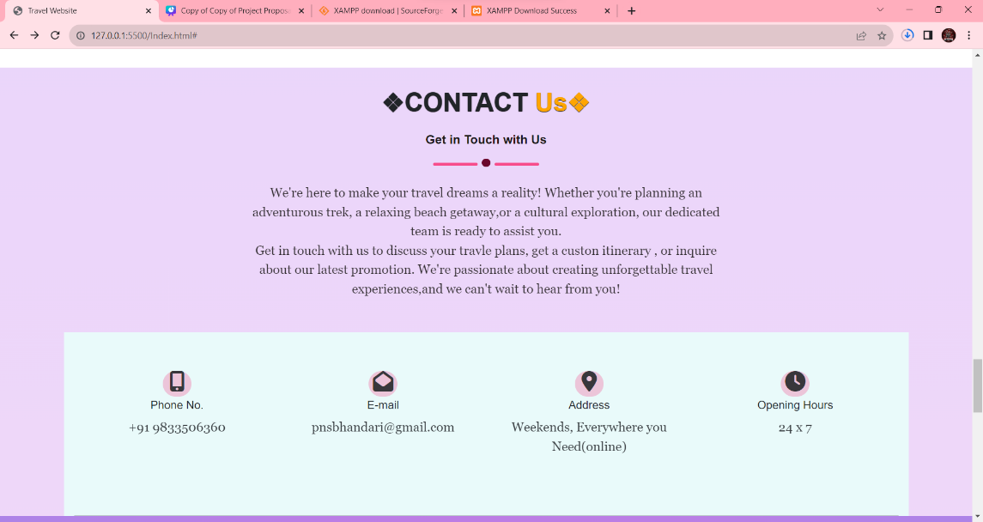

6

  - ANALYSIS

1.User Interface: Evaluate the user-friendliness of the system’s interface. Is it easy for tourists to navigate and access information about tourist destinations, accommodations, and activities?

2.Database Management: Assess the efficiency of the database management system. Are tourist data, booking information.

3.Security: Evaluate the security measures in place to protect users’ personal information and financial data. Is there encryption and protection against cyber threats?

4.Integration: Consider how well the system integrates with other services, such as transportation and local guides. Does it provide a seamless experience for tourists?

5.Scalability: Assess the potential for scalability. Can the system handle an increasing number of users and transactions without performance issues?

6.Cost Efficiency: Determine the cost-effectiveness of the system. Is it efficient in terms of both initial development and ongoing maintenance costs?

7. Feedback and Improvement: Analyze how user feedback is used to improve the system. Is there a feedback loop for continuous enhancements?

This small-scale analysis can provide insights into the strengths and weaknesses of the tourist management system in India and help identify areas for improvement. Keep in mind that in a real-world scenario, this analysis would involve more in-depth research and data collection.

7

3.7 CONCLUSION AND FUTURE WORK

Conclusion:

- The "Tourist Management System" is a revolutionary tool that streamlines and enhances the management processes involved in the realm of travel and tourism. It is designed to provide fast, efficient, and secure services to travelers, tour operators, and other stakeholders in the industry. The system boasts several key features that set it apart from traditional methods of managing travel.
- One of the most significant advantages of this system is its speed and immediate results. With the integration of modern technology and high-performance computing, the system can process a multitude of travel-related tasks with remarkable speed and precision. This translates into quicker booking and reservation processes, ensuring that travelers receive timely and accurate information, which is paramount for a hassle-free travel experience.
- Furthermore, the Tourist Management System excels in ensuring high-security standards. In an age where data breaches and security threats are ever-present concerns, this system prioritizes safeguarding sensitive information, such as personal and financial data. This not only protects the privacy of travelers but also safeguards the reputation and integrity of the entire tourism industry.

Future Work:

8

4. REFERENCE

[1] Author1, Author2, “title of paper”, in conference name/journal name, PP-, Vol, year
[2] Times New Roman, 12
[3] How To Create Travel & Tour Website Using HTML CSS & BOOTSTRAP 5 - YouTube
[4] How to connect login/signup to database using php and mysql - YouTube

9

